X xc

**Building Partnerships**

Tara Elementary offers ongoing events to build partnership with families. Parents are encouraged to participate in the following school activities:

* Meet and Greet
* Annual Title I Meeting
* Curriculum Night
* Parent Teacher Conferences
* Parent Academy Workshops
* GMAS Parent Information
* School Council
* Volunteering/Observing
* PTA
* Compact, Policy and 1% Input Meeting

#### What is a

#### School-Parent Compact?

Tara’s School-Parent Compact offer ways that we can work together to help our students succeed. This compact provides strategies to help connect learning at school and at home.

Effective Compacts:

* Link to academic achievement goals
* Focus on student learning
* Share strategies that staff, parents, and students can use
* Explain how parents and teachers can communicate about student progress
* Describe opportunities for parents to observe, volunteer, and participate in the classroom

**TARA ELEMENTARY SCHOOL-PARENT COMPACT**

**2019-2020**

**Excellence is the ONLY choice**

# K-5th Grade



Communication about Student Learning

Tara Elementary is committed to frequent two-way communication with families about students’ learning. We will actively keep parents informed and build strong positive relationships through:

* Frequent reports to parents on their children’s progress.
* Parent-teacher conferences
* Reasonable access to staff, opportunities to volunteer and participate in their child’s class, and observe classroom activities.
* Providing information through the use of
* school marquee and website
* phone calls and school messenger
* emails and text messages
* Monthly calendar, Flyers and letters
* Weekly homework folders/binders
* Infinite Campus Parent Portal

**Jointly Developed**

The teachers, parents, and students of Tara Elementary jointly developed this School-Parent Compact for Achievement. Teachers suggested home learning strategies, parents added ideas to make them more specific, and students told us what would help them learn. Input meetings are held each year to review the compact and make changes based on student needs. **Parents are welcome to contribute comments at any time.**

If you would like to volunteer, participate, and observe in the classroom, please contact Ms. Yetsenia Figueroa, parent liaison at 770-968-2916 or email: [yetsenia.figueroa@clayton.k12.ga.us](mailto:yetsenia.figueroa@clayton.k12.ga.us).

**Dr. Wakea N. Brown, Principal**

**937 Mt. Zion Rd. Morrow, Georgia 30260 Phone: 770-968-2916**

**Revised: August 30, 2019**



**Our Goals for Student Achievement**

**Teachers, Parents, Students – Together for Success**

**As a school, we will:**

* Provide families with reading practice through homework assignments.
* Provide families with school home connection reading activities to increase phonics, fluency, and comprehension skills.
* Provide families with reading websites focused on building students’ phonics, fluency, and comprehension skills.

**As parents, we will:**

* Ensure our students complete the reading practice homework assignments provided by the teacher.
* Encourage our students to read daily for 30 minutes and ask them comprehension questions.
* Ensure our students use the websites provided to practice phonics, fluency and comprehension skills.
* Review and check my child’s grades regularly on Infinite Campus

# District Goals 2019-2020

By the end of the 2020 school year, Clayton County Public Schools will increase the percentage of students scoring at Proficient and/or Distinguished levels on the Georgia Milestones to at least 3% in each content area.

**Tara Elementary School Goals**

**2019-2020**

By 2019-2020, Tara Elementary School will increase the percentage of students scoring at the Proficient and/or Distinguished levels on the Georgia Milestones to at least 3% in each content area to meet the district goal by 2023.



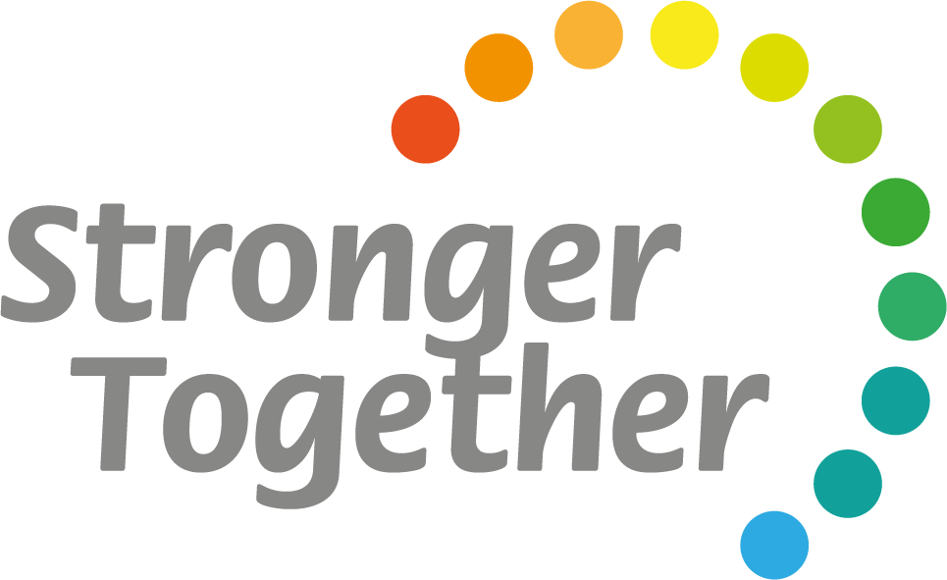

**As students, we will:**

* Read daily for at least 30 minutes to increase fluency and comprehension.
* Use the websites provided by our teachers to help improve comprehension.
* Complete the reading practice homework assignments provided by the teacher.
* I will be responsible, respectful, and persistent (School wide Goals)