X xc

**Building Partnerships**

Tara Elementary offers ongoing events to build partnership with families. Parents are encouraged to participate in the following school activities:

* Meet and Greet
* Annual Title I Meeting
* Curriculum Night
* Parent Teacher Conferences
* Parent Academy Workshops
* Grade Level Parent Meetings
* GMAS Parent Information
* School Council
* Volunteering/Observing
* PTA
* Compact, Policy and 1% Input Meeting
* Parent and Family Engagement Resource Center

**SCHOOL-PARENT COMPACT**

**FOR ACHIEVEMENT**

**2018-2019**

**Revised September 28, 2018**

# K-5th Grade

# Focus for

# Student Success

# C:\Users\yfigueroa\Documents\images (2).jpg

#### What is a

#### School-Parent Compact?

A *School-Parent Compact for Achievement* is an agreement that parents, students, and teachers develop together. It explains how parents and teachers will work together to make sure all of our student’s reach grade level standards.

Effective compacts:

* Link to goals of the school improvement plan
* Focus on student learning skills
* Describe how teachers will help students develop those skills using high-quality instruction
* Share specific strategies parents can use at home
* Explain how teachers and parents will

Communicate about student progress

* Describe opportunities for parents to volunteer, observe, and participate in the classroom.

Communication about Student Learning

Tara Elementary is committed to frequent two-way communication with families about students’ learning. We will actively keep parents informed and build strong positive relationships through:

* Frequent reports to parents on their children’s progress.
* Parent-teacher conferences at least twice a year where this compact will be discussed as the compact relates to the individual child’s achievement.
* Reasonable access to staff, opportunities to volunteer and participate in their child’s class, and observe classroom activities.
* Providing information through the use of
* school marquee and website
* phone calls and school messenger
* emails and text messages
* Monthly calendar, Flyers and letters
* Weekly homework folders/binders
* Infinite Campus Parent Portal



**Jointly Developed**

The teachers, parents, and students of Tara Elementary jointly developed this School-Parent Compact for Achievement. Teachers suggested home learning strategies, parents added ideas to make them more specific, and students told us what would help them learn. Input meetings are held each year during spring and the fall 2018 to review the compact and make changes based on student needs.

**Parents are welcome to contribute comments at any time.**

If you would like to volunteer, participate, and observe in the classroom, please contact Ms. Yetsenia Figueroa, parent liaison at 770-968-2916 or email: [yetsenia.figueroa@clayton.k12.ga.us](mailto:yetsenia.figueroa@clayton.k12.ga.us).

**Dr. Wakea N. Brown, Principal**

**937 Mt. Zion Rd. Morrow, Georgia 30260, Phone: 770-968-2916**

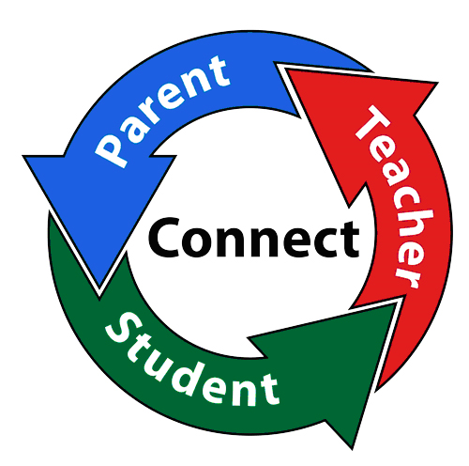

**Teachers, Parents, Students – Together for Success**

**Our Goals for Student Achievement**

**As parents, we will:**

* Ensure our students complete the reading practice homework assignments provided by the teacher.
* Encourage our students to read daily for 30 minutes and ask them comprehension questions.
* Ensure our students use the websites provided to practice phonics, fluency and comprehension skills.
* Use study guides provided to help our students practice and prepare for reading assessments.
* I will attend Parent Academy Workshops to learn how to help my child with reading.
* Visit Tara’s Parent Resource Center to get materials and resources to help my child with reading at home.

**As a school, we will:**

* Provide families with reading practice through homework assignments.
* Provide families with school home connection reading activities to increase phonics, fluency, and comprehension skills.
* Provide families with reading websites focused on building students’ phonics, fluency, and comprehension skills.
* Provide families with study guides to use at home to help their students practice and prepare for reading assessments.

# District Goals 2018-2019

By 2023, Clayton County Public Schools will increase the percentage of students scoring at the Proficient and/or Distinguished levels on the Georgia Milestones to at least 80% in each content area.

**Tara Elementary School Goals**

**2018-2019**

By 2023, Tara Elementary School will increase the percentage of students scoring at the Proficient and/or Distinguished levels on the Georgia Milestones to at least 80% in each content area.

By May 2019, Tara Elementary School will increase the percentage of K-1 students on DIBELS at the Benchmark and Above Benchmark Levels by 10%

By May 2019, Tara Elementary School will demonstrate 10% growth in grades 2nd – 5th in Reading on I-Ready.



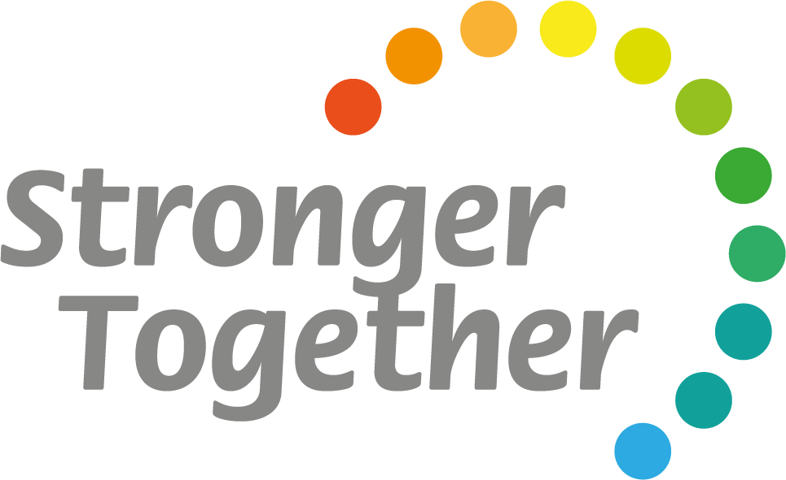

**As students, we will:**

* Read daily for at least 30 minutes to increase fluency and comprehension.
* Use the websites provided by our teachers to help improve comprehension.
* Complete study guides to practice and prepare for reading assessments.
* Complete the reading practice homework assignments provided by the teacher.
* I will answer both verbal and written statements with complete sentences both at home and at school.